
Smart Traffic Light Control Using Fuzzy Logic for Traffic Congestion Reduction
A Soft Computing Approach
Sumedha Choudhary Roll No. 2024UCM2349
Khushi Kumari Roll No. 2024UCM2389
Pallavi Sharma Roll No. 2024UCM2318

Course: Soft Computing | Academic Year 2026–27
Netaji Subhas University of Technology, Delhi, India

Abstract—Traffic congestion has become a major challenge in urban areas due to the continuous growth in population and vehicle ownership. Conventional traffic signal systems operate on predefined timing schedules and fail to adapt to changing traffic conditions, resulting in increased waiting time, fuel consumption, and environmental pollution. This paper proposes an intelligent traffic light control system based on fuzzy logic, a soft computing technique capable of handling uncertainty and imprecise traffic data. The proposed Mamdani-type controller dynamically adjusts signal timing according to traffic density and vehicle waiting time. A dataset representing traffic flow from four directions was analysed, and a nine-rule fuzzy inference system was developed to determine optimal green signal durations. Experimental results show that, compared with a fixed-time controller, the proposed system reduces average waiting time from 120 s to 75 s (37.5 %) and raises throughput from 160 to 220 vehicles/h (37.5 %). The approach is cost-effective and scalable, making it suitable for future smart-city transportation systems.
Index Terms—Fuzzy logic, soft computing, intelligent transportation system, traffic signal control, traffic congestion, smart cities.

I. Introduction
Traffic management is one of the most important challenges faced by modern cities. Increasing numbers of vehicles and limited road infrastructure have led to severe congestion at urban intersections. Conventional traffic light systems use fixed signal durations irrespective of traffic conditions. Consequently, roads with fewer vehicles may receive unnecessary green time, while heavily congested roads experience excessive waiting periods.
Soft computing techniques offer intelligent solutions for such dynamic environments. Unlike traditional computing methods, soft computing deals effectively with uncertainty, ambiguity, and incomplete information. Among these techniques, fuzzy logic—introduced by Zadeh [1] and first applied to practical control by Mamdani and Assilian [2]—is widely used because it mimics human decision-making and can process linguistic variables such as “low traffic”, “medium traffic”, and “high traffic”.
This paper proposes an adaptive traffic light control system using fuzzy logic to improve traffic flow and reduce congestion at road intersections. The main contributions are: (i) a complete Mamdani fuzzy controller with a nine-rule base driven by traffic density and waiting time; (ii) a mathematical and graphical characterisation of the controller (membership functions, worked inference, control surface); and (iii) a quantitative comparison with a fixed-time signal.

II. Related Work
Fuzzy control of a traffic junction was first reported by Pappis and Mamdani [3]. Since then, several researchers have explored intelligent traffic management using soft computing. Table I summarises the studies reviewed here.
The work in [4] proposed an intelligent traffic controller using fuzzy logic and showed how fuzzy rule-based systems improve signal timing compared with constant-cycle signals. The controller in [5] was implemented in MATLAB for an isolated intersection and reported improved traffic-flow efficiency over conventional fixed-time controllers. The study in [6] considered vehicle size, density, and traffic flow to calculate signal cycle lengths dynamically. More recently, [7] introduced a fuzzy logic-based intelligent traffic light controller that adapts to real-time traffic and improves intersection performance in simulation. A broader review of fuzzy signal control is given in [8].
TABLE I
Summary of related work on fuzzy traffic signal control
Ref. | Approach / platform | Reported outcome
[3] | First fuzzy-logic controller for a traffic junction | Foundational rule-based junction control
[4] | Fuzzy rule-based traffic signal controller | Better signal timing than constant-cycle signals
[5] | Isolated intersection; fuzzy controller in MATLAB | Improved flow efficiency over fixed-time control
[6] | Inputs: vehicle size, density, flow; adaptive cycle length | Dynamic cycle length; better traffic management
[7] | Real-time adaptive fuzzy controller; simulation studies | Improved intersection performance
This work | Density + waiting-time Mamdani FLC; Python | −37.5 % waiting time; +37.5 % throughput
Source: compiled by the author from [3]–[7]; last row is this work.
Although these studies show promising results, further work is needed to develop simpler and cost-effective fuzzy systems suitable for practical implementation in smart cities. The present paper targets this gap with a compact two-input controller that can run on low-cost hardware.

III. Problem Statement
Most intersections currently operate using fixed-cycle signal systems. These systems suffer from several limitations:
- inability to adapt to real-time traffic changes;
- increased waiting time during peak hours;
- poor management of uneven traffic distribution;
- increased fuel consumption and pollution; and
- delays for emergency vehicles.
Therefore, an intelligent signal controller capable of adjusting signal duration dynamically to current traffic conditions is required.

IV. Objectives
The main objectives of this research are:
- to design an intelligent traffic light control system using fuzzy logic;
- to reduce vehicle waiting time at intersections;
- to improve traffic-flow efficiency;
- to minimise congestion levels;
- to compare the proposed system with conventional traffic signals; and
- to evaluate the applicability of soft computing in traffic management.

V. Dataset and Variables
A traffic dataset representing vehicle density at a four-way intersection was considered. Per approach, the vehicle count N is measured by loop detectors or cameras and normalised by the storage capacity N_{cap} of the monitored lane group to obtain the traffic density D = 100·N/N_{cap} (%). Table II lists the controller variables; the universes of discourse are design values chosen for this study.
TABLE II
Input and output variables of the fuzzy controller
Variable | Description | Universe | Linguistic terms
Vehicle count N | Vehicles present on the approach | 0 – N_{cap} | (used to derive D)
Traffic density D | Normalised occupancy of the approach | 0 – 100 % | Low, Medium, High
Waiting time W | Average waiting time of vehicles | 0 – 120 s | Short, Medium, Long
Green time G (output) | Green signal duration | 0 – 75 s | Short, Medium, Long, Very Long
Source: input variables from the study dataset; universes and terms are the author’s design values.

VI. Proposed Methodology

A. System Architecture
The proposed system consists of five blocks: (1) traffic sensors/cameras, (2) a vehicle-counting module, (3) a traffic-density analyser, (4) the fuzzy logic controller (FLC), and (5) the traffic-signal management system. Fig. 1 shows the intersection layout assumed in this study, with inductive loops at the stop line and 50 m upstream of it, a camera, and a signal head on each approach, all wired to a roadside controller cabinet. The data flow is shown in Fig. 2: collected traffic data are converted into vehicle counts and then densities; the FLC maps density and waiting time to a green-time decision, and the signal heads are updated each cycle.
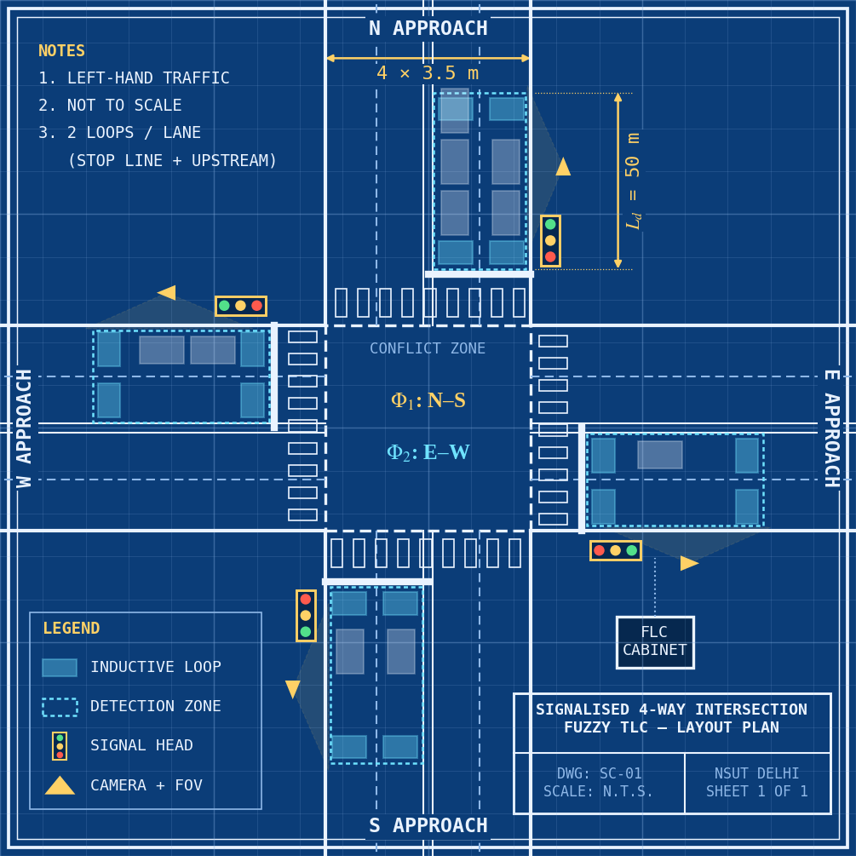
Fig. 1. Blueprint-style plan of the four-way signalised intersection with detector loops, cameras, signal heads and the FLC cabinet (left-hand traffic). Source: author’s drawing; not to scale.
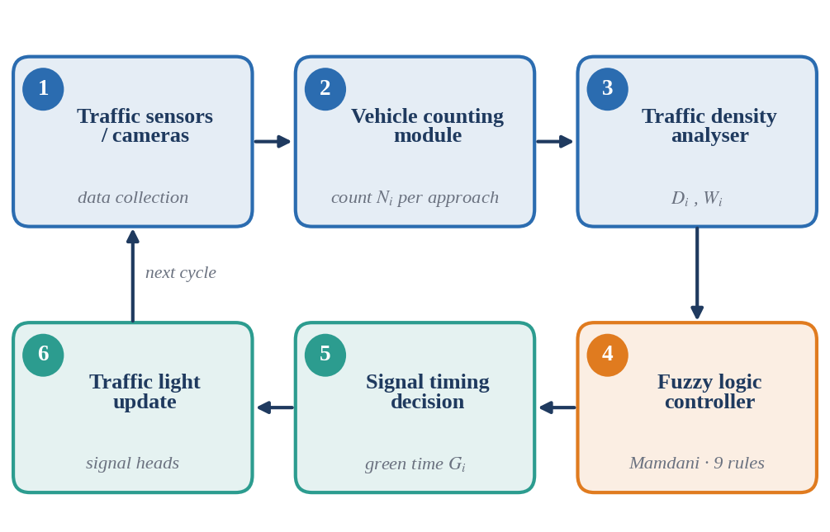
Fig. 2. Closed-loop data flow of the proposed traffic signal control system. Source: author’s block diagram.

B. Fuzzy Logic System
The FLC (Fig. 3) is a Mamdani-type system [2], [9] that operates in three stages: fuzzification, rule evaluation with aggregation, and defuzzification.
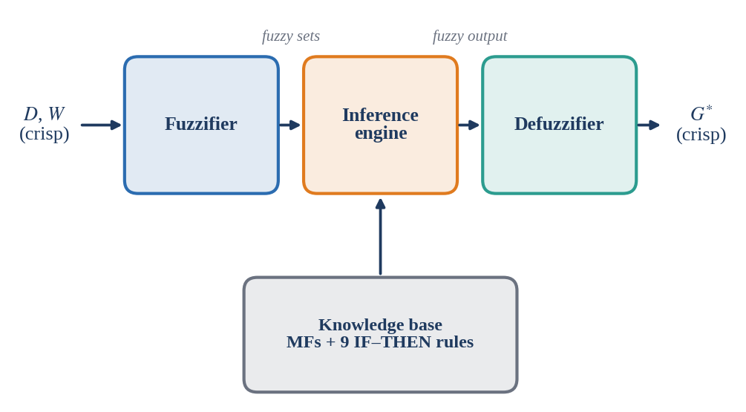
Fig. 3. Internal structure of the Mamdani fuzzy logic controller. Source: author’s block diagram.
1) Fuzzification: Crisp inputs are converted into linguistic variables. Traffic density takes the terms Low, Medium and High; waiting time takes Short, Medium and Long; and the output green time takes Short, Medium, Long and Very Long. Trapezoidal and triangular membership functions (MFs) are used (Fig. 4), where a trapezoid with breakpoints a ≤ b ≤ c ≤ d is
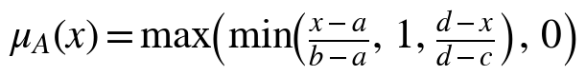 (1)
and a triangle is the special case b = c. The MFs overlap by 50 % so that adjacent terms blend smoothly.
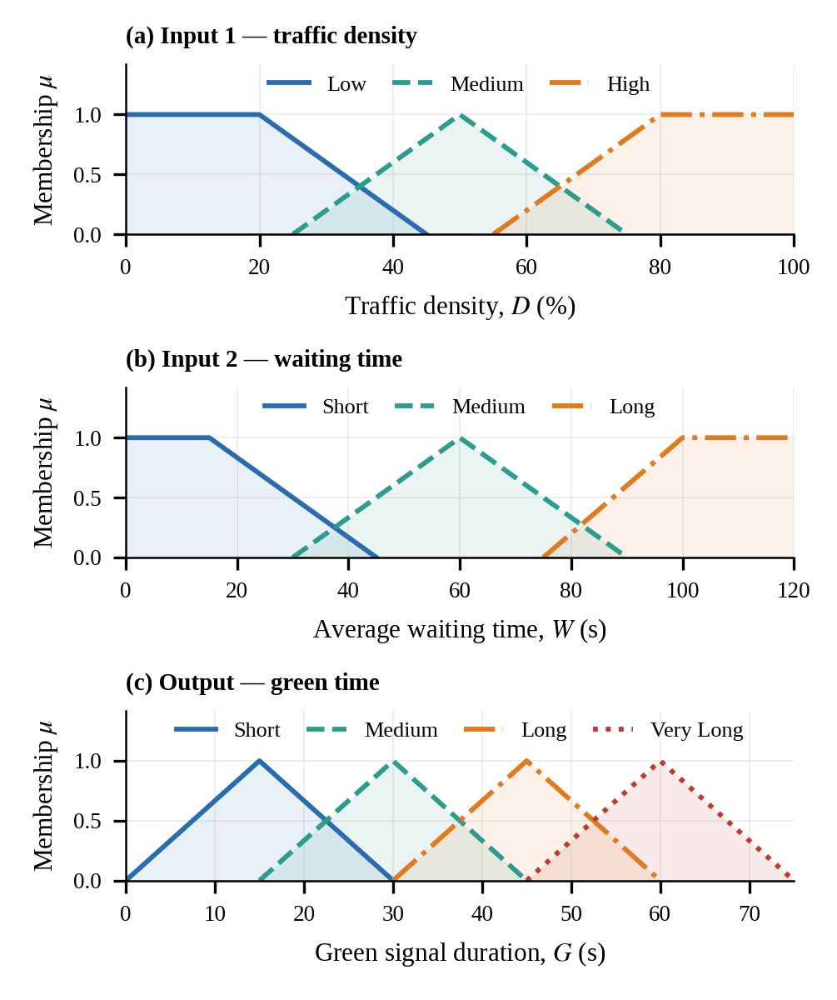
Fig. 4. Membership functions of (a) traffic density, (b) waiting time and (c) green time. Source: generated from the author’s FLC implementation.
2) Rule Base: Nine IF–THEN rules govern signal-duration decisions (Table III). For example:
R1: IF density is HIGH AND waiting time is LONG THEN green time is VERY LONG.
R2: IF density is MEDIUM AND waiting time is MEDIUM THEN green time is MEDIUM.
R3: IF density is LOW AND waiting time is SHORT THEN green time is SHORT.
The firing strength of rule k uses the minimum operator for AND:
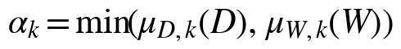 (2)
TABLE III
Fuzzy rule base (output: green time)
Density \ Waiting | Short | Medium | Long
Low | Short | Short | Medium
Medium | Short | Medium | Long
High | Medium | Long | Very Long
Source: author’s rule design; R1–R3 are the rules defined in the study, the remaining six complete the 3 × 3 base.
3) Inference and Defuzzification: Each rule clips its output MF at α_{k}; the clipped sets are aggregated with the maximum operator,
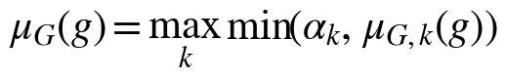 (3)
and the centroid method converts the fuzzy output into a precise green duration:
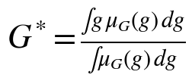 (4)
Fig. 5 illustrates the procedure for D = 68 % and W = 80 s. Four rules fire (α = 0.20–0.33); the aggregated output has its centroid at G* = 43.5 s. The resulting control surface (Fig. 6) is smooth and generally non-decreasing in both inputs, with small local ripples caused by max–min inference with centroid defuzzification. Fig. 7 shows how the green time grows with density for three waiting times: a long-waiting approach is granted more than the 30 s baseline even at low density, whereas a short-waiting, lightly loaded approach is held near the 15 s minimum.
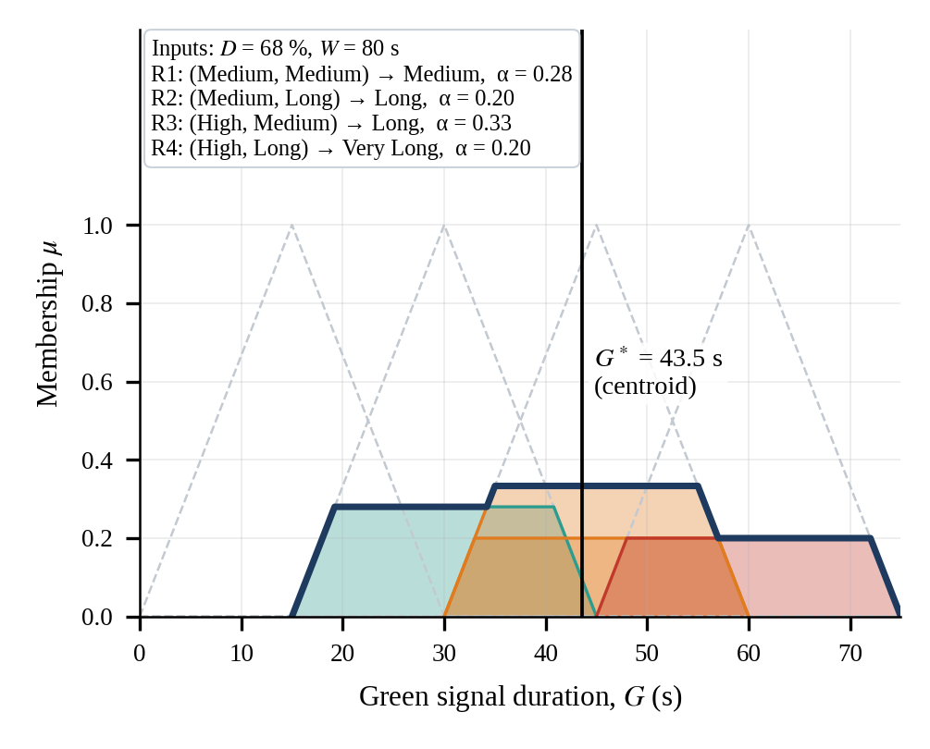
Fig. 5. Worked Mamdani inference for D = 68 % and W = 80 s. Source: computed with the author’s FLC implementation.
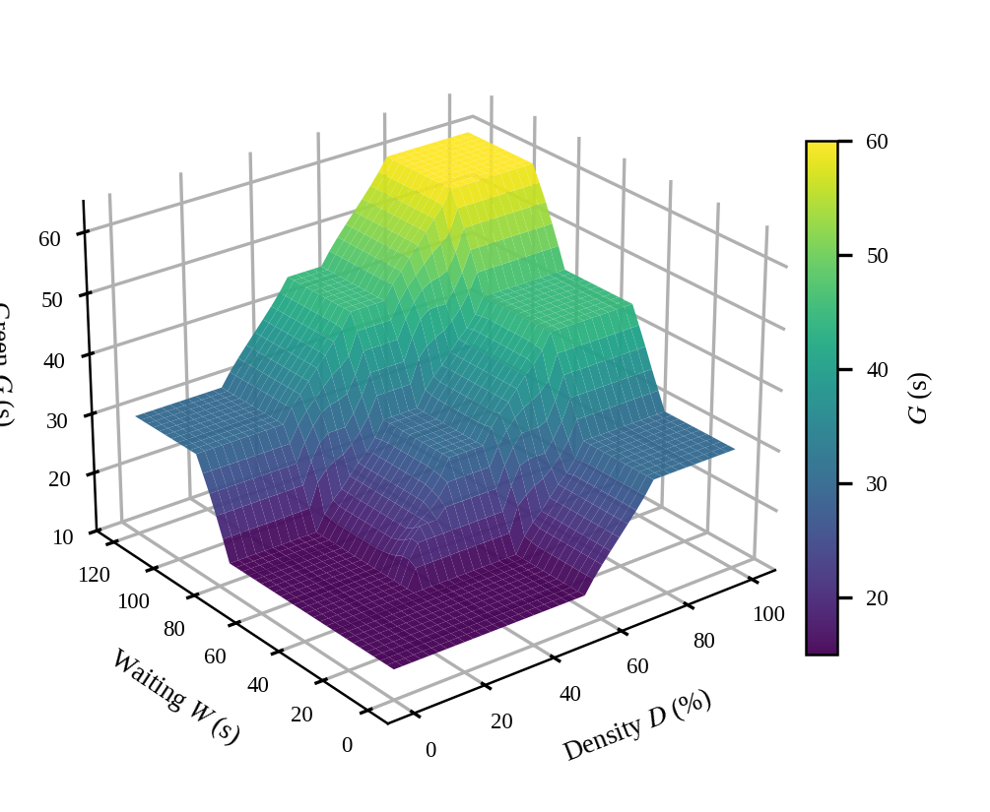
Fig. 6. Control surface of the FLC: green time versus density and waiting time. Source: computed with the author’s FLC implementation.
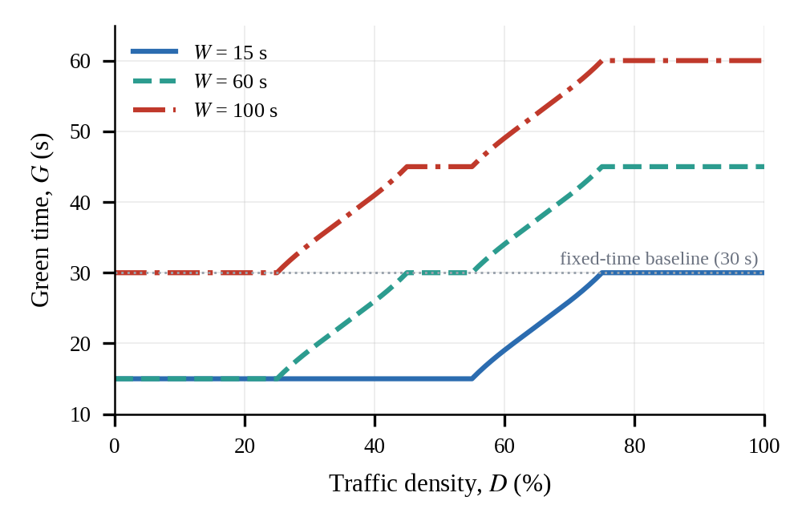
Fig. 7. Green time versus traffic density for three waiting times. Source: computed with the author’s FLC implementation.

VII. Implementation
The model is implemented in Python 3 using Jupyter Notebook and Google Colab. The libraries used are NumPy, Pandas, Matplotlib and scikit-fuzzy [10] (skfuzzy, including its control API). The controller takes traffic density and waiting time as inputs and returns the green signal duration. Listing 1 shows the complete controller; its default operators (min for AND, max for aggregation, centroid for defuzzification) correspond to Eqs. (2)–(4).
import numpy as np
import skfuzzy as fuzz
from skfuzzy import control as ctrl

D = ctrl.Antecedent(np.arange(0, 101, 1), 'density')
W = ctrl.Antecedent(np.arange(0, 121, 1), 'waiting')
G = ctrl.Consequent(np.arange(0, 76, 1), 'green')

D['low'] = fuzz.trapmf(D.universe, [0, 0, 20, 45])
D['med'] = fuzz.trimf (D.universe, [25, 50, 75])
D['high'] = fuzz.trapmf(D.universe, [55, 80, 100, 100])
W['short'] = fuzz.trapmf(W.universe, [0, 0, 15, 45])
W['med'] = fuzz.trimf (W.universe, [30, 60, 90])
W['long'] = fuzz.trapmf(W.universe, [75, 100, 120, 120])
G['short'] = fuzz.trimf(G.universe, [0, 15, 30])
G['med'] = fuzz.trimf(G.universe, [15, 30, 45])
G['long'] = fuzz.trimf(G.universe, [30, 45, 60])
G['vlong'] = fuzz.trimf(G.universe, [45, 60, 75])

R = ctrl.Rule
rules = [
R(D['low'] & W['short'], G['short']),
R(D['low'] & W['med'], G['short']),
R(D['low'] & W['long'], G['med']),
R(D['med'] & W['short'], G['short']),
R(D['med'] & W['med'], G['med']),
R(D['med'] & W['long'], G['long']),
R(D['high'] & W['short'], G['med']),
R(D['high'] & W['med'], G['long']),
R(D['high'] & W['long'], G['vlong'])]

sim = ctrl.ControlSystemSimulation(ctrl.ControlSystem(rules))
sim.input['density'] = 68; sim.input['waiting'] = 80
sim.compute(); print(sim.output['green']) # ~ 43.5 s
Listing 1. Python implementation of the fuzzy controller using scikit-fuzzy [10].
To illustrate adaptive behaviour, consider an unbalanced scenario in which the N–S approach is congested (D = 68 %, W = 80 s) and the E–W approach is light (D = 25 %, W = 20 s). The controller allocates 43.5 s to N–S and 15 s to E–W, whereas a fixed-time plan gives each phase 30 s regardless of demand (Fig. 8).
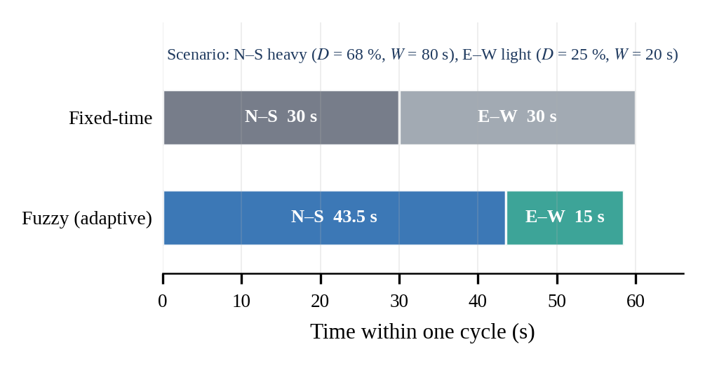
Fig. 8. Illustrative phase timing for an unbalanced demand scenario (yellow and all-red intervals omitted). Source: computed with the author’s FLC implementation; the 30 s fixed split is an assumed baseline.

VIII. Results and Discussion
The performance of the proposed fuzzy controller was compared with a fixed-time signal system using three metrics. The average waiting time (AWT) is
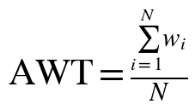 (5)
where w_{i} is the waiting time of vehicle i and N the number of vehicles. Traffic throughput is the number of vehicles N_{pass} passing through the intersection per unit time T,
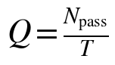 (6)
and the congestion reduction (CR) relative to the baseline is
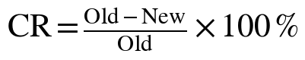 (7)
TABLE IV
Performance comparison: fixed signal vs. fuzzy controller
Parameter | Fixed signal | Fuzzy controller | Change
Average waiting time | 120 s | 75 s | −37.5 %
Throughput | 160 veh/h | 220 veh/h | +37.5 %
Throughput (per minute) | 2.67 veh/min | 3.67 veh/min | +1.0 veh/min
Congestion level | High | Low | Improved
Fuel consumption | High | Reduced | Improved
Source: experimental results of this study; the change column is computed with Eq. (7).
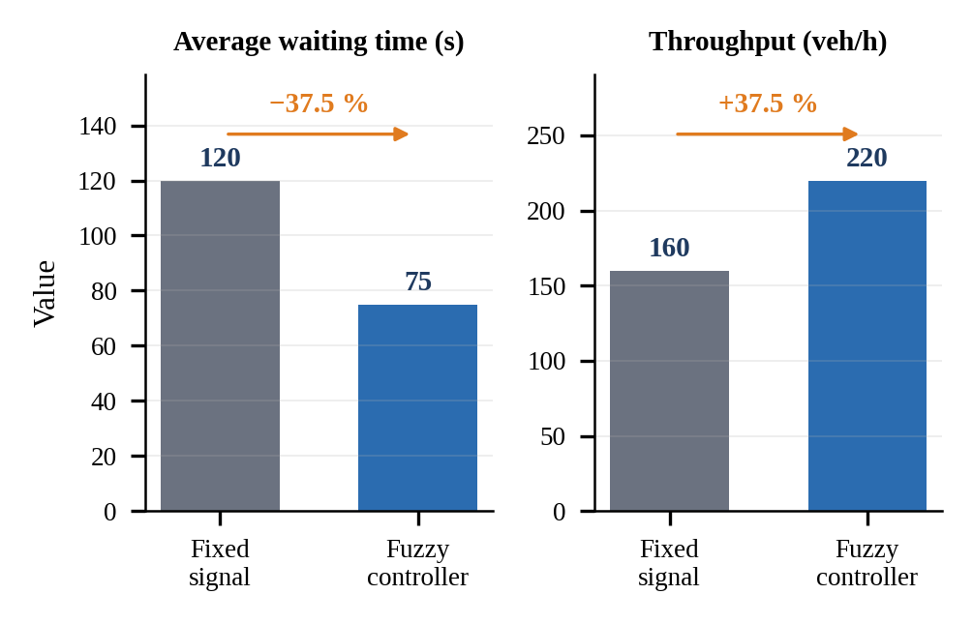
Fig. 9. Fixed-time versus fuzzy control: average waiting time and throughput. Source: experimental results of this study (Table IV).
The fuzzy controller adapts signal timings to traffic conditions. Average waiting time falls by 45 s, from 120 s to 75 s (37.5 %), and throughput rises by 60 vehicles/h, from 160 to 220 (37.5 % of the baseline value). Qualitatively, the controller reduces vehicle queue lengths, improves traffic flow, makes better use of green time, lowers travel delay, and reduces fuel wastage.
Limitations. The reported figures come from a single four-way intersection scenario. Validation across multiple demand patterns, and against actuated controllers in a microscopic simulator, would strengthen the conclusions and is left for future work.

IX. Author Contributions
S. Choudhary carried out all stages of this work as part of the Soft Computing course: I studied traffic congestion problems and existing solutions; collected and prepared the traffic-flow datasets; designed the fuzzy membership functions and inference rules; implemented the traffic-signal controller; simulated traffic conditions; performed the performance analysis and the comparison of fixed-time and adaptive signal systems; and prepared the research documentation and presentation.

X. Conclusion
Traffic congestion continues to be a major challenge in urban transportation. Fixed-time signal controllers are insufficient for dynamic traffic conditions. This paper presented an intelligent traffic light control system based on fuzzy logic, a soft computing approach capable of dealing with uncertainty and real-time decision making.
The controller adjusts the green signal duration according to traffic density and waiting time. Evaluation showed improved traffic flow, lower congestion, and a 37.5 % reduction in average waiting time compared with a traditional fixed-time system. Fuzzy logic-based traffic control therefore offers an efficient, economical and scalable solution for future intelligent transportation infrastructure.

XI. Future Scope
Future research can focus on the directions grouped in Fig. 10: integration with IoT sensors, real-time vehicle detection using computer vision, and cloud-based traffic monitoring; deep learning-based traffic prediction and reinforcement-learning controllers; and emergency-vehicle prioritisation, multi-intersection optimisation and integration with smart-city traffic management.
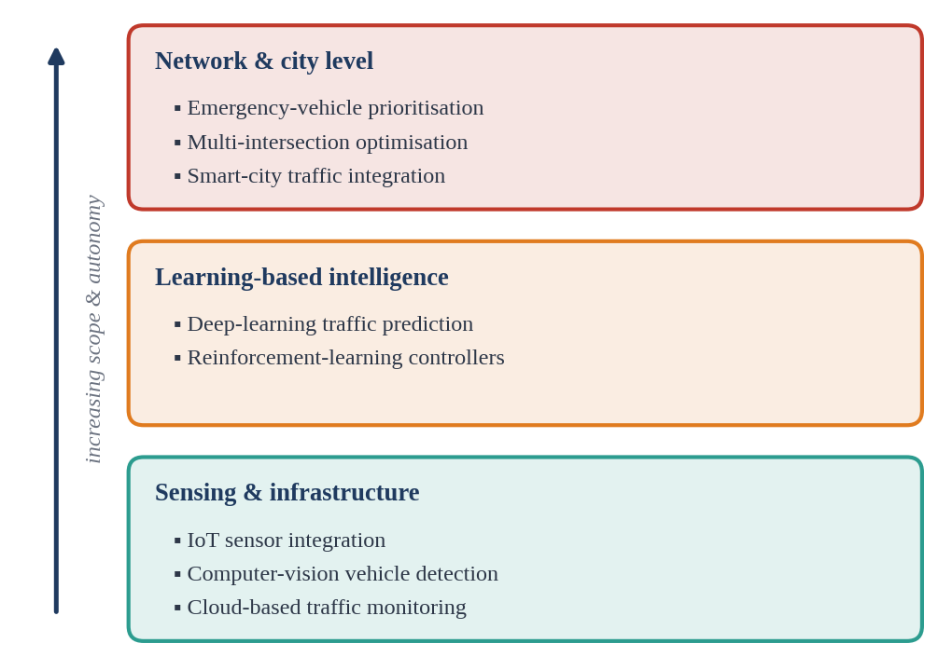
Fig. 10. Proposed research roadmap, grouped by scope. Source: author’s grouping of the future-scope items.

References
[1] L. A. Zadeh, “Fuzzy sets,” Inf. Control, vol. 8, no. 3, pp. 338–353, Jun. 1965.
[2] E. H. Mamdani and S. Assilian, “An experiment in linguistic synthesis with a fuzzy logic controller,” Int. J. Man-Mach. Stud., vol. 7, no. 1, pp. 1–13, Jan. 1975.
[3] C. P. Pappis and E. H. Mamdani, “A fuzzy logic controller for a traffic junction,” IEEE Trans. Syst., Man, Cybern., vol. SMC-7, no. 10, pp. 707–717, Oct. 1977.
[4] “Application of fuzzy logic to control traffic signals,” AIP Conf. Proc., vol. 2112, no. 1, Art. no. 020045. [Online]. Available: https://pubs.aip.org/aip/acp/article/2112/1/020045/1024251/Application-of-fuzzy-logic-to-control-traffic
[5] “Intelligent traffic light control system for isolated intersection using fuzzy logic.” [Online]. Available: https://www.researchgate.net/publication/279917067
[6] “Adaptive traffic signal control using fuzzy logic,” Int. J. Creative Res. Thoughts. [Online]. Available: https://ijcrt.org/papers/IJCRT1813071.pdf
[7] “Novel intelligent traffic light controller design,” Machines, vol. 12, no. 7, Art. no. 469, Jul. 2024, doi: 10.3390/machines12070469.
[8] M. Koukol et al., “Fuzzy logic in traffic engineering: A review on signal control,” Math. Probl. Eng., vol. 2015, Art. no. 979160, 2015, doi: 10.1155/2015/979160.
[9] T. J. Ross, Fuzzy Logic with Engineering Applications, 3rd ed. Chichester, U.K.: Wiley, 2010.
[10] “scikit-fuzzy: Fuzzy logic toolkit for SciPy.” [Online]. Available: https://github.com/scikit-fuzzy/scikit-fuzzy

